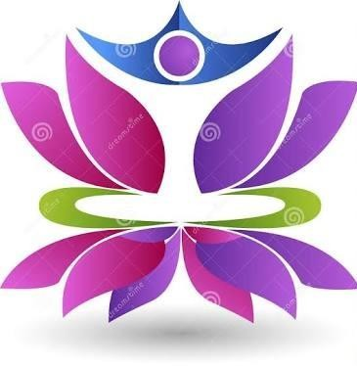

ANNUAL REPORT-2022-23

Office Add: 209, Dhadiwal Layout, Ringroad, Behind MRF Showroom, Suyog Nagar, At po Parvati nagar dist Nagpur

Reg.NO. F-25127/Nag



I PLEDGE
- To Help every day, those who are needed
- To express in words, actions and deeds, our gratitude towards our elders our parents & grandparents
- To do my duty for those who fulfilled theirs,
- To love, respect and care for the people in my family and community.
ANNUAL REPORT 2022-23

SHRI SANT VIKTESHWAR BEDIWALE BABA SANSTHA is a
non-profit making charitable society (NGO) for promotion of education and welfare activities registered in the 2008 and has been working hard since its establishment for the education and other various welfare programs, increasing the literacy rate, better health and propriety of the rural and slum area specially for scheduled Tribes community. We are trying for the creation of the knowledge society by increasing literacy rate and in agriculture and allied fields through pooling of human physical, social and economic resources for the welfare of

rural and urban ST/SC community. We have continued our efforts during the year from 2008 till today with tremendous hope and anticipation about the rural community, farmers, unemployed youths, women and children upliftment , which are enumerated as below.

SHRI SANT VIKTESHWAR BEDIWALE BABA SANSTHA is
Shri Sant Viketeshwar Bediwalebaba Sanstha, Nagpur, 209- Dhadiwal Lay-out, Ring Road, Behind MRF Showroom, Nagpur-440027 is the registered society under Society Registration Act. 1860 and Bombay Public Trust Act. 1950. On dated 16 May 2008. The Society is functioning in Training & Workshop in Agriculture, Livelihood for ST, Corporation school garden, Agronomy, Horticulture, Extension Education Service Farm Machinery Workshop (Leather /Carpentry/Pump repairing /Welding/Cycle repairing-cum-petromax-cum-solar lantern repair), Fishery ,Dairy, Poultry, Bee-keeping, watershed development awareness, Socio-economic development, and Senior Citizen Day care center for Dementia, youth affairs and sports, self-employment for women and social empowerment of women. As well as this organization works in work as Health, Education, Social-work, Community work, Child Labour Strict children, Computer Training, workshops, Sanitation, Drug Awareness and treatment, Community health organization, Medicare Unit for Senior citizens, Mobile Hospital for ST/SC Category, Old Age Home for women. CPLL and ODIC for Substance abuse Recovery and rehabilitation with awareness. As well as we working on recovering addicts training and rehabilitation formed by the educational, cultural, environmental improvement and Social Workers for the upliftment of the down trodden community, especially for the vulnerable class of the society and those who belong to ( ST) Scheduled Tribes , scheduled castes ( SC ), and OBC. Most of the people belonging to the said community are deprived of physical, Education, Economical, and other field, they have not made the desired progress.

This Organization has been very prompt in order to find the solutions to the problem raise in the field of education, women and children belonging to weaker and backward class community and has been active in solving major aspects of education and unemployment, economical, social health and all other related problem.
The organization has been engaged in the welfare and development activities which are meant for the cause of the welfare of the weaker of the weaker sections of the rural and slum community.

The organization has identified the basic need of human being, about the education, agriculture, health, nutrition, unemployment and tried to solve through the counseling etc. Various activities have been undertaken by the organization in the year 2023-24 as follow.

VISION:

Our vision is to change the future of orphans and vulnerable children through the love god and family

MISSION:

Our mission is to break the cycle of poverty by providing holistic development to impoverished orphans, widows and leprecy affected people in India. Through meeting their physical, educational, spiritual and social needs. To challenge and equip children to live productive and responsible live

Extension And education service:
Extension education is a way to provide learning opportunities to people who aren't enrolled in formal schooling. It can include adult education, professional development,and youth engagement.

Purpose
- To help people learn new skills and improve their practices
- To help people make decisions based on their local conditions
- To help people solve problems in their communities

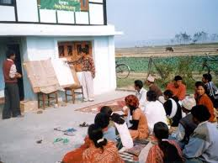

Bee keeping :
Beekeeping training can include learning how to care for bees, handle beehives, and use bees for pollination. You can get beekeeping training at recognized training centers and through courses.
- Sustainable beekeeping principles include:
  - Keeping local bees
  - Using structural hives that are similar to natural bee homes
  - Spacing out hives
  - Ethical honey harvesting
  - Planting native forage
  - Operating treatment-free hives
  - Practicing minimal interference

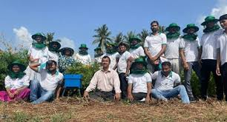

- Poutry Farming Workshop Visit:

The course "Poultry Farming" comprises of theory and practical components and are intended to provide basic knowledge and technical skills in the areas of Poultry Feeding, Housing, Management, Health Care and Marketing. During the course of your study, NIOS will treat you as the manager of your learning

Training topics
- Animal care: Learn about different breeds of chicken and how to care for them
- Nutrition: Learn about gut health and nutrition for poultry
- Marketing: Learn how to market poultry products and how to overcome challenges
- Disease management: Learn about respiratory training, breeder management, and disease training
- Antimicrobials: Learn how to use antimicrobials responsibly
- Parasitology: Learn about parasites that affect poultry

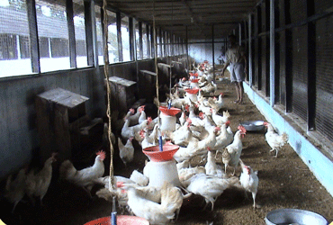

Workshop on leather Carpentry:
In a leather workshop, individual leather requirements from customers are fulfilled. This includes repairing belts, bags, shoes and jackets as well as manufacturing items, from single objects to small production runs. In a leather workshop, there are many tools and machines for leather processing.

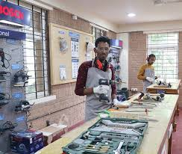

Practical Workshop on Agronomy

Agronomy workshops can cover topics such as soil and water management, crop management, and pest management. Workshops can also focus on natural farming and sustainable practices.
Topics covered in agronomy workshops
Soil and water management: Soil properties, site characterization, soil erosion, and water quality
Crop management: Cropping systems, crop establishment, crop growth, and crop production economics
Pest management: Pest identification, sampling, monitoring, and pest management strategies
Nutrient management: Basic concepts of plant nutrition, soil testing, and nutrient sources
Natural farming: Training farmers to promote natural farming and solve farm problems
Sustainable practices: Identifying and assessing agricultural practices to enhance productivity, food security, and resilience

- 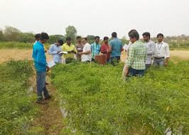

Women Health Awareness Programme :

According to world health organization maximum AIDS affected person are belonging to developed and under developed countries. India is developing country and we observe many kind of disease. Like chicken guniya, MEASALES , AIDS, TB, DIBETIES ED ETC. for that reason we have conducted a camp on AIDS awareness and immunization.

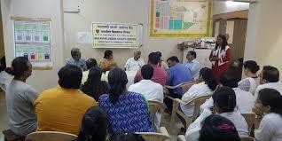

Blood Group check up camp in schools:

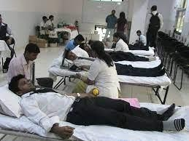
Based on the importance of blood group we have arranged this camp with the assistance from lab technician in Nagpur. In which near about 200 men and women participated
guidance given to all beneficiaries about its importance by our lab technician at the same time.

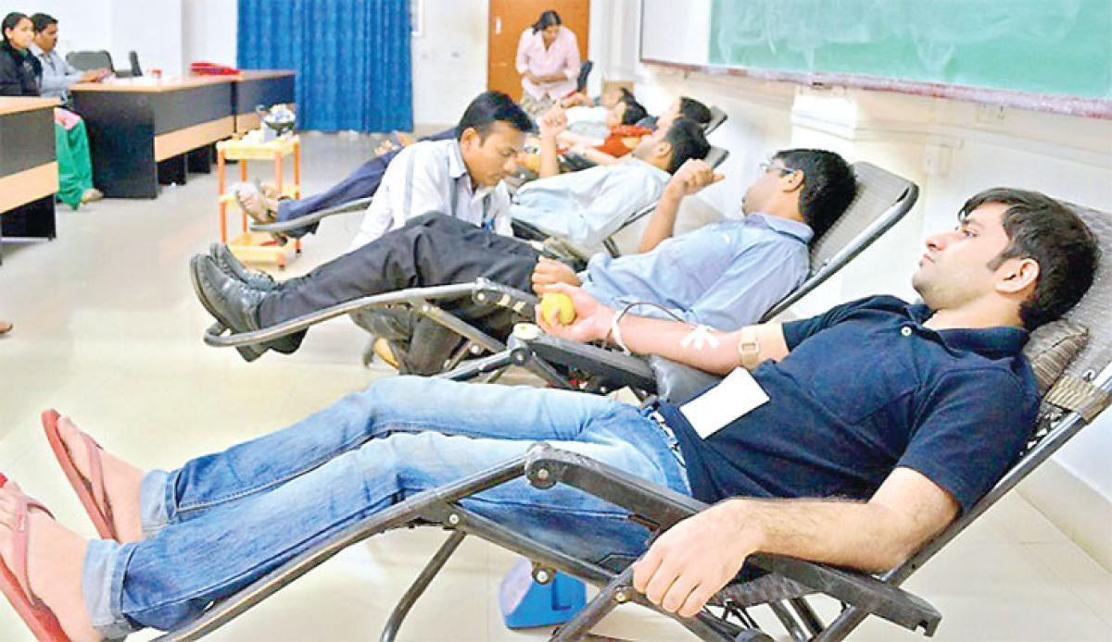
Blood Donation :

The main reason to donate blood is to save a life so you must never think twice to donate blood. It is a sign of humanity. It doesn't see the caste, creed, and religion of the blood donor. Furthermore, the organs in our body conduct different functions and these organs need energy and oxygen to function properly.
Importance of donating blood
- Blood donation is a selfless act of kindness that can save lives.
- Blood is needed for many medical treatments, including surgeries, cancer treatments, and blood disorders.
- Blood donation helps blood banks maintain a safe blood supply.
- Blood donation can help improve heart health.

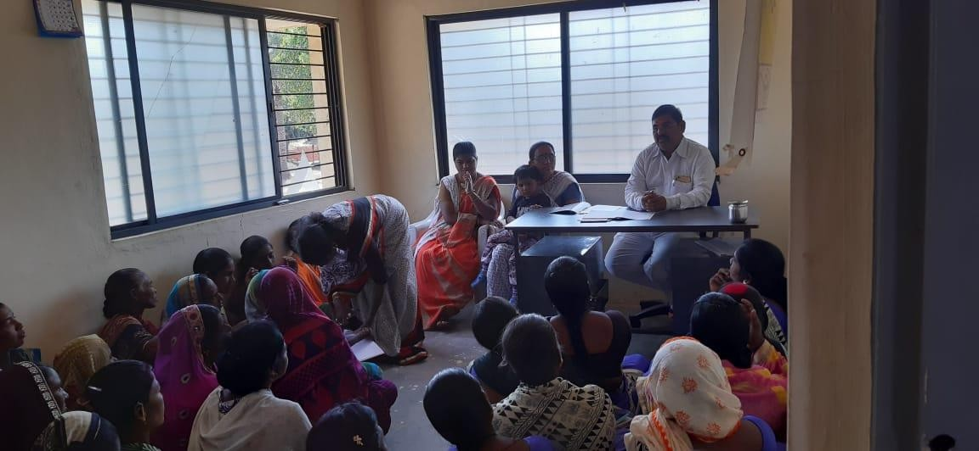
SHGs capacity building and guidance camp:

We have conducted camp on SHGs training and capacity building. We are working in the field of advance farming and allied sector, cattle raring and dairy development. We have provided guidance on milk product and dairy formation.

- Financial literacy program:

We are working in the field of women empowerment social development skill development economic development o f the women and girls, training to SHGs and micro financing. We have conducted program on financial literacy at organization office Nagpur

- Vocational training program:

We are working in the field of skill development, vocational training, youth and leadership development. We have conducted many camps and training program on vocational training, career development, youth’s personality development. We have conducted this program at Nagpur
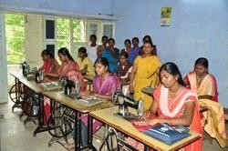

- Women legal rights program:

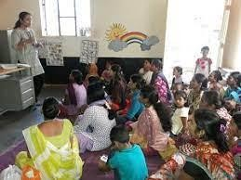
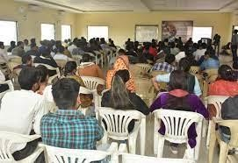
We are working in the field of women and child development, women empowerment and skill development. We also conducted women leadership program. We have conducted legal awareness program At Nagpur .

YOUTH DEVELOPMENT PROGRAM

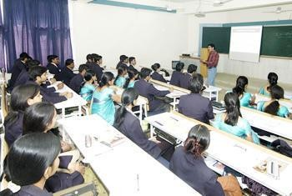
Youths are the future of India we have good number of youths but we have to create skillful youths and educated youths. We also conducted women leadership program. For this we conducted youth development camps At Nagpur . Our Organization has arranged the matches for youth (boys and girls) with the co-operation of municipal members from the respective wards. Prizes were distributed at the end of tournament.

